My mobile application documentation week six assignment
- The week six assignment which was about building a complete, production-ready Student Management and Analytics Mobile Application which must cleanly integrate local database architectures, asynchronous networking, full CRUD event handling, and a highly customizable user interface into a single, perfectly working codebase. The mobile application has the following comprehensive architecture and feature specifications:
1.Architecture and reuse state management:
- Pattern: Implement a clean Model-View-View model architecture separating UI screens, View models, and Data Repositories.
- State Handling: Use state holders to securely manage and persist UI states across system configuration changes.
- Navigation: Establish a functional safe route transition. Include a global Bottom Navigation Bar for flawless navigation between primary modules.
2 Specific application modules and screens: (6 Screens Required):
- Login Screen: A modern authentication page featuring functional form state verification, explicit input fields validation, and error notification behaviors.
- Dashboard Screen: A responsive hub featuring a modern layout with quick-action tiles acting as the central gateway to all modules.
- Student Registration Screen: An interactive data entry form with functional event handling to register new students.
- Reports Screen: A data visualization and listing screen featuring a high-performance that computes and displays registration metrics.
- Local Database (CRUD) Module: A dedicated panel to search, display, update details, or delete student records seamlessly.
- Settings Screen (UI Customization Module): An interactive control interface featuring a text field to instantly change the App Title text globally, a slider to adjust App Font Size, and a selection row of color icons to dynamic-swap the App Background color on the fly.
3. Data interaction and robust system coupling:
- Local Storage: Implement a local relational database using Room Database entities and DAOs to store, retrieve, filter, and delete student data records permanently.
- API Integration & Networking: Use Retrofit to asynchronously consume a public REST API (e.g., retrieving online user profiles). Ensure data parsing handles JSON payloads safely.
- Functional Error Handling: Enforce comprehensive try-catch architecture at the repository level. Gracefully catch and display descriptive UI warning feedback for slow networks, unexpected JSON mismatches, or connection losses.
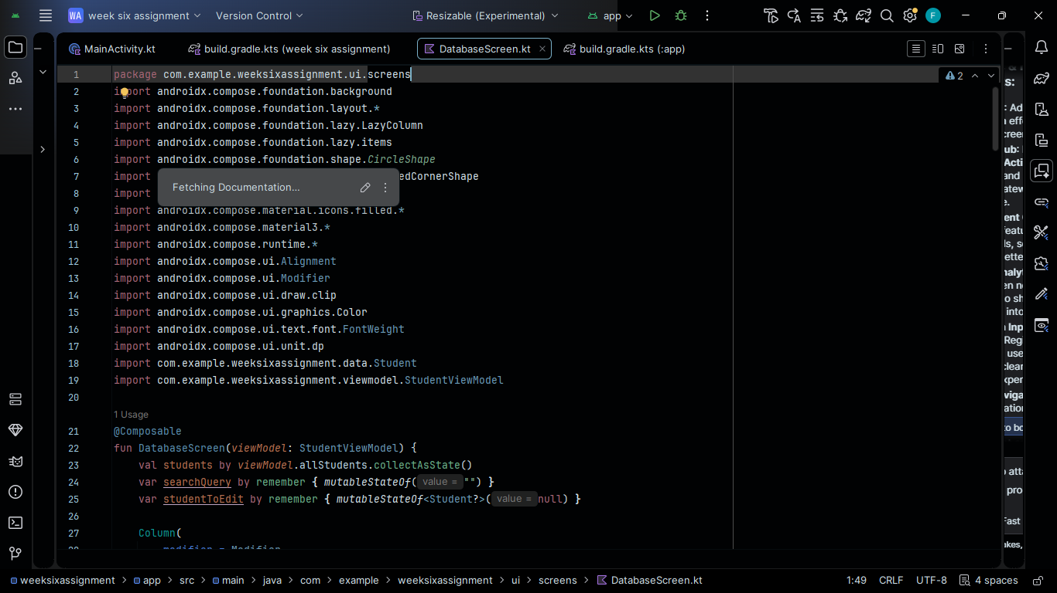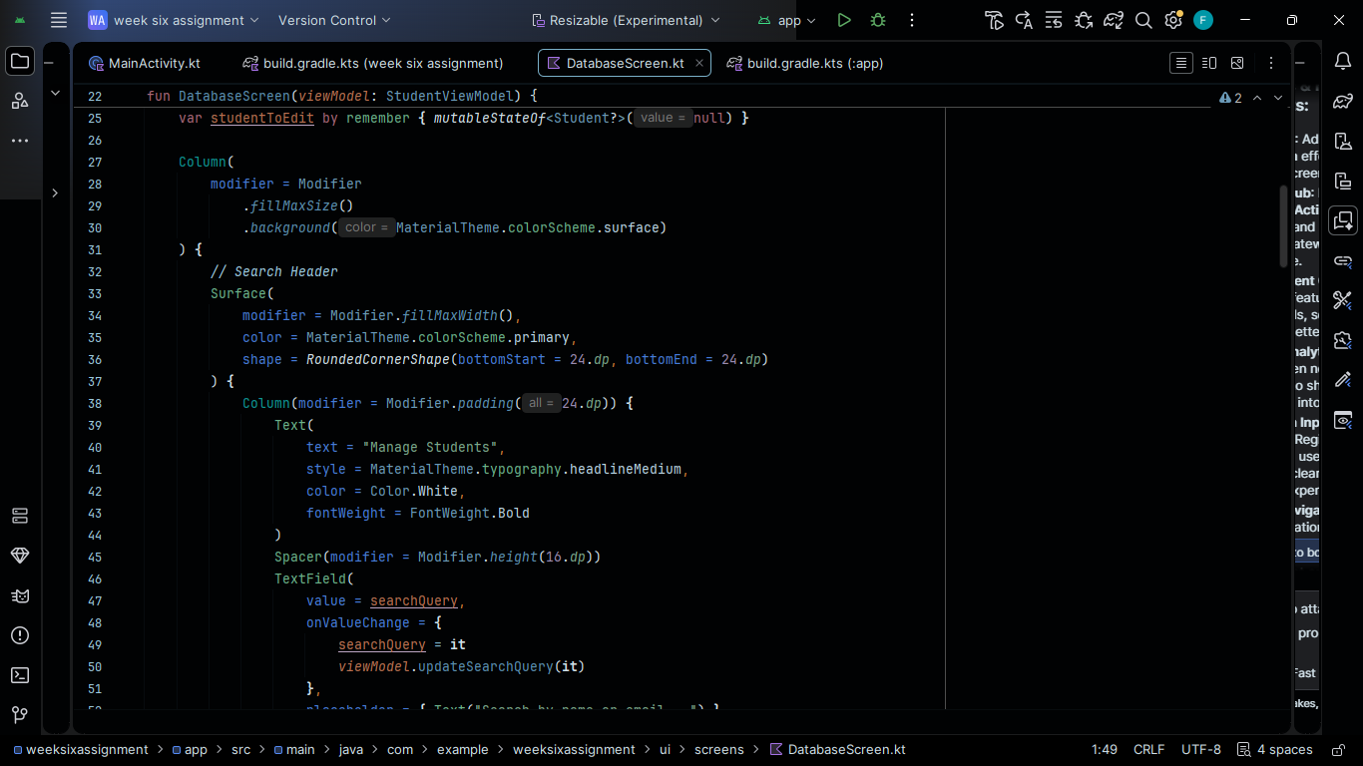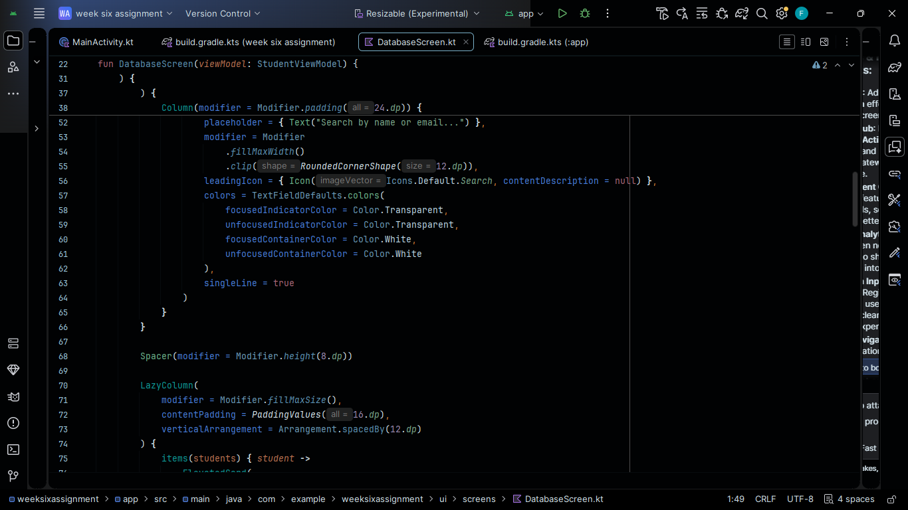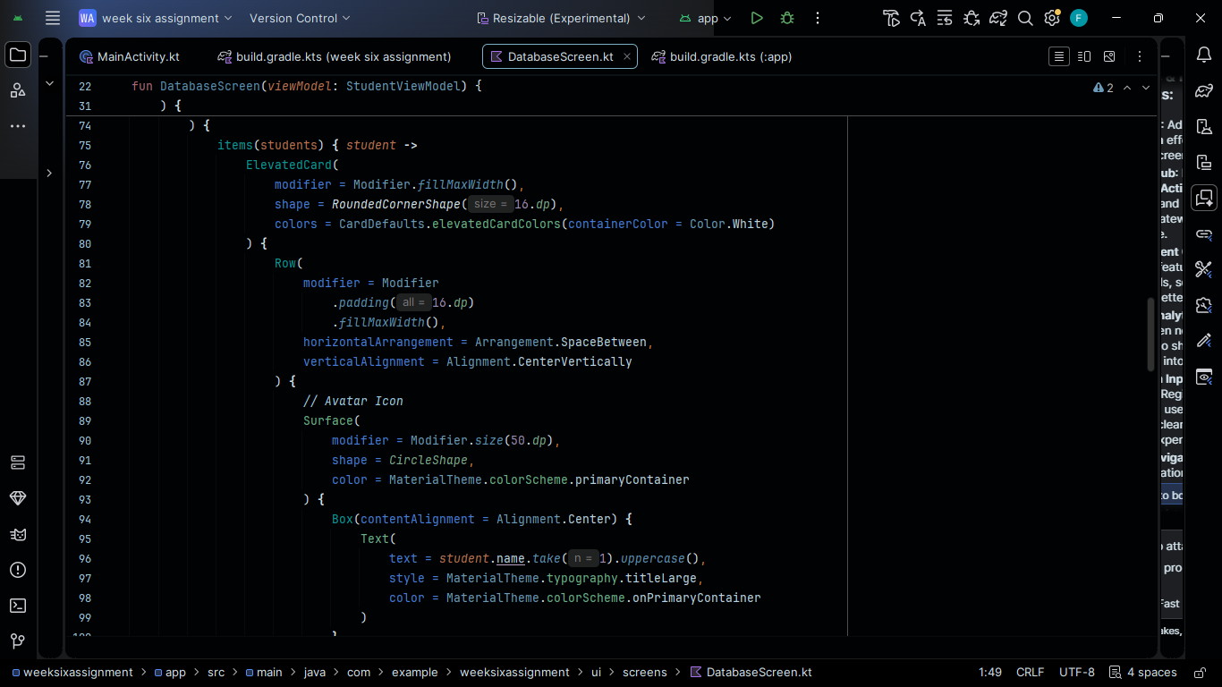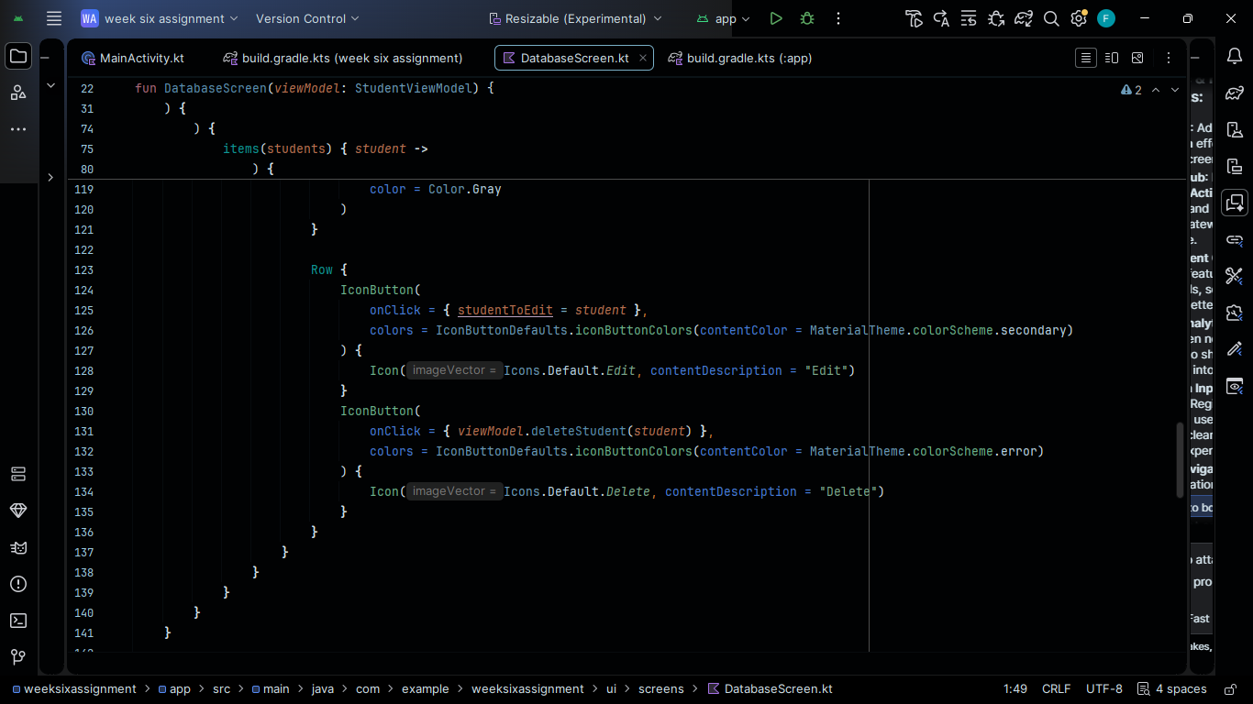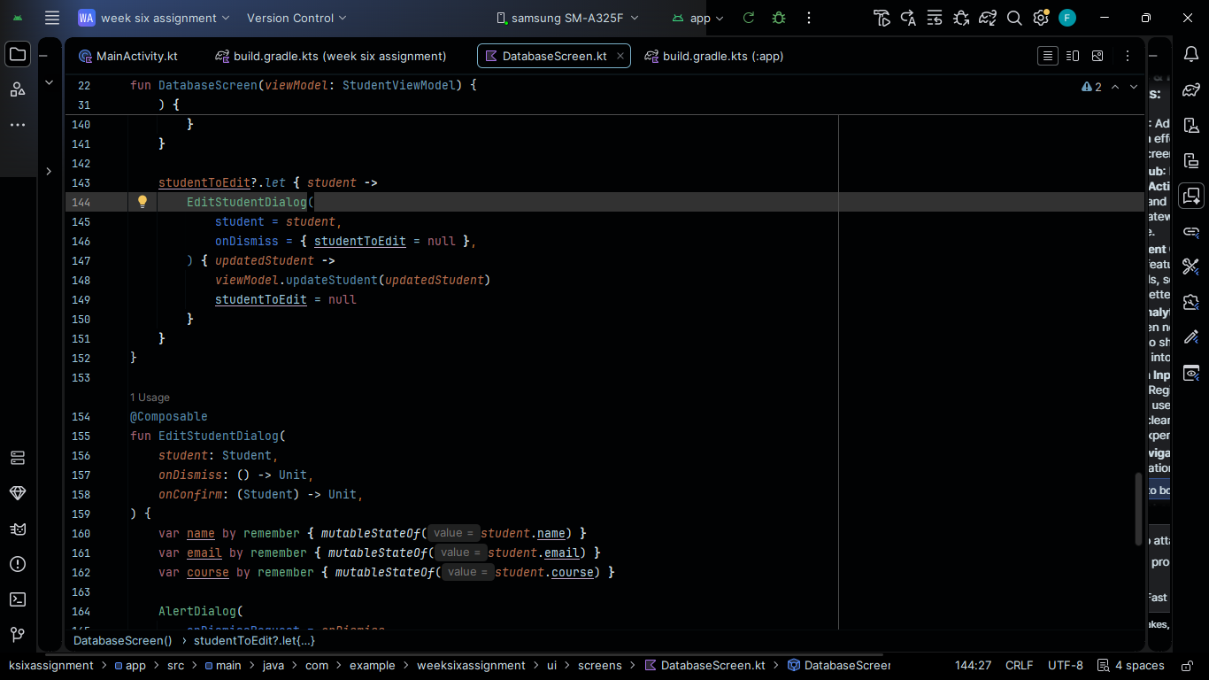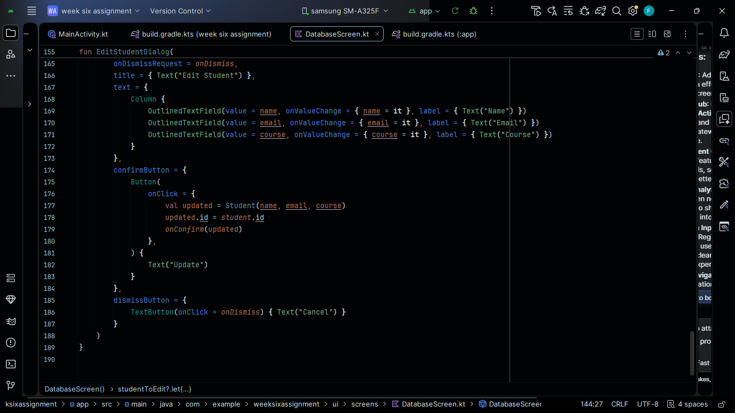
The app displayed looks like:

